**BANK LOAN REPORT QUERY DOCUMENT**

**Bank Loan Report / KPI’s:-**

**1.Total Loan Application**

select COUNT(id) as Totoal_application from bank_loan_data

**2.MTD Loan Application (Month to date Application)**

**3.PMTD Loan Application(Previous Month to date application )**

select count(id) as Total_application from bank_loan_data where MONTH(issue_date)=11;

**4.Total Funded Amount**

select sum(loan_amount)as Total_Funded_Amount from bank_loan_data;

**5.MTD Total Funded Amount**

select sum(loan_amount)as Total_Funded_Amount from bank_loan_data where MONTH(issue_date)=12;

**6.PMTD Total Funded Amount**

select sum(loan_amount)as Total_Funded_Amount from bank_loan_data where MONTH(issue_date)=11;

**7. Total Amount Received**

select sum(total_payment)as Total_Amount_Collected from bank_loan_data;

**7.MTD Total Amount Received**

select sum(total_payment)as Total_Amount_Collected from bank_loan_data where MONTH(issue_date)=12;

**7. PMTD Total Amount Received**

select sum(total_payment)as Total_Amount_Collected from bank_loan_data where MONTH(issue_date)=11;

**8.Average interest rate**

select AVG(int_rate)*100 as Avg_rate_intrest from bank_loan_data;

select AVG(int_rate)*100 as Avg_rate_intrest from bank_loan_data;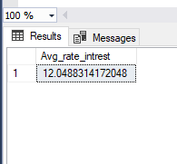

**9.MTD Average interest rate**

select AVG(int_rate)*100 as Avg_rate_intrest from bank_loan_data where MONTH(issue_date)=12;

**10.PMTD Average interest rate**

select AVG(int_rate)*100 as Avg_rate_intrest from bank_loan_data where MONTH(issue_date)=11;

**11. Average DTI**

select AVG(dti)*100 as Avg_dti from bank_loan_data;

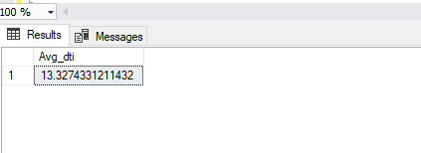

**12.MTD Average DTI**

select AVG(dti)*100 as Avg_dti from bank_loan_data where MONTH(issue_date)=12;

**13.PMTD Average DTI**

select AVG(dti)*100 as Avg_dti from bank_loan_data where MONTH(issue_date)=11;

**Good Loan Issued:-**

**1.Good Loan Percentage**

select (COUNT (case when loan_status='Fully Paid' or loan_status='Current' then id end)*100)/COUNT(id) as Good_loan_percentage from bank_loan_data

**2. Good Loan Application**

select count(id) as Good_loan_application from bank_loan_data where loan_status='Fully Paid' or loan_status='Current';

**3. Good Loan Funded Amount**

select sum(loan_amount) as good_loan_funded_amount from bank_loan_data where loan_status='Fully Paid' or loan_status='Current'

**4. Good Loan Amount Received**

select sum(total_payment) as good_loan_amount_recived from bank_loan_data where loan_status='Fully Paid' or loan_status='Current'

**Bad Loan Issued:-**

**1.Bad Loan Percentage**

select (COUNT (case when loan_status='Charged Off' then id end)*100)/COUNT(id) as Bad_loan_percentage from bank_loan_data

**2. Bad Loan Application**

select count(id) as Bad_loan_application from bank_loan_data where loan_status='Charged Off'

**3. Bad Loan Funded Amount**

select sum(loan_amount) as Bad_loan_funded_amount from bank_loan_data where loan_status='Charged Off'

**4. Bad Loan Amount Received**

select sum(total_payment) as Bad_loan_amount_recived from bank_loan_data where loan_status='Charged Off'

**Loan Status:-**

select loan_status,

COUNT(id) as loanCount,

sum(total_payment) as Total_amount_recived,

sum(loan_amount) as Total_funded_amount,

avg(int_rate*100) as avg_intrest_rate,

avg(dti *100) as DIT

from bank_loan_data

SELECT

loan_status,

SUM(total_payment) AS MTD_Total_Amount_Received,

SUM(loan_amount) AS MTD_Total_Funded_Amount

FROM bank_loan_data

WHERE MONTH(issue_date) = 12

GROUP BY loan_status

**Bank Loan Report/Overview:-**

**Month**

SELECT MONTH(issue_date) as month_number,

DATENAME(month,issue_date) as Month_name,

count(id) as total_loan_application,

sum(loan_amount) as total_funded_amount,

sum(total_payment) as total_amount_received from bank_loan_data

group by month(issue_date),DATENAME(month,issue_date)

order by month(issue_date)

**State**

SELECT

address_state AS State,

COUNT(id) AS Total_Loan_Applications,

SUM(loan_amount) AS Total_Funded_Amount,

SUM(total_payment) AS Total_Amount_Received

FROM bank_loan_data

GROUP BY address_state

ORDER BY address_state

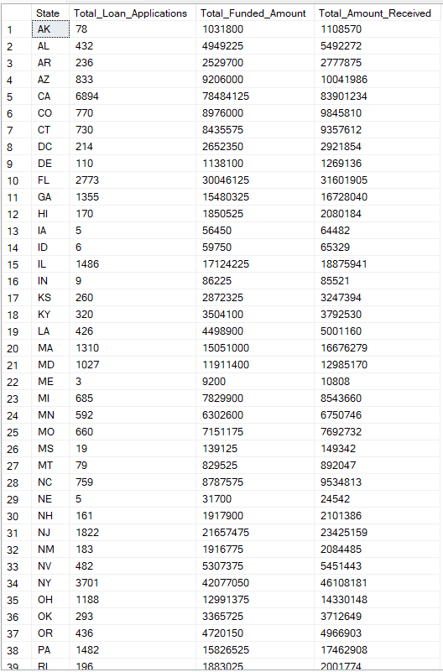

**Term**

SELECT

term AS Term,

COUNT(id) AS Total_Loan_Applications,

SUM(loan_amount) AS Total_Funded_Amount,

SUM(total_payment) AS Total_Amount_Received

FROM bank_loan_data

GROUP BY term

ORDER BY term

**Employee Length**

SELECT

emp_length AS Employee_Length,

COUNT(id) AS Total_Loan_Applications,

SUM(loan_amount) AS Total_Funded_Amount,

SUM(total_payment) AS Total_Amount_Received

FROM bank_loan_data

GROUP BY emp_length

ORDER BY emp_length

**Purpose**

SELECT

purpose AS PURPOSE,

COUNT(id) AS Total_Loan_Applications,

SUM(loan_amount) AS Total_Funded_Amount,

SUM(total_payment) AS Total_Amount_Received

FROM bank_loan_data

GROUP BY purpose

ORDER BY purpose

**Home Owership**

SELECT

home_ownership AS Home_Ownership,

COUNT(id) AS Total_Loan_Applications,

SUM(loan_amount) AS Total_Funded_Amount,

SUM(total_payment) AS Total_Amount_Received

FROM bank_loan_data

GROUP BY home_ownership

ORDER BY home_ownership

Note: We have applied multiple Filters on all the dashboards. You can check the results for the filters as well by modifying the query and comparing the results.

For e.g

See the results when we hit the Grade A in the filters for dashboards.

*SELECT*

*purpose AS PURPOSE,*

*COUNT(id) AS Total_Loan_Applications,*

*SUM(loan_amount) AS Total_Funded_Amount,*

*SUM(total_payment) AS Total_Amount_Received*

*FROM bank_loan_data*

*WHERE grade = 'A'*

*GROUP BY purpose ORDER BY purpose*